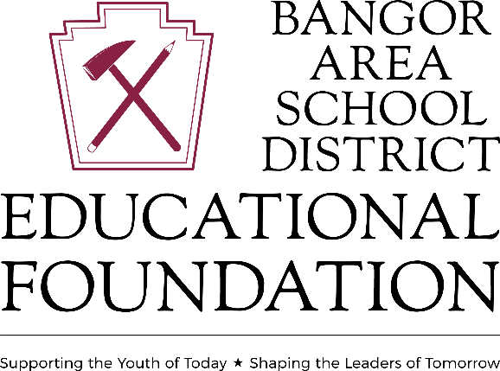

The Portland Morekan Scholarship
This $4,000 annual scholarship will be awarded to a graduating Bangor Area High School Senior based on academic ability, service to others, cultivation of interests or abilities, and written and oral communication skills. If the scholarship recipient maintains a minimum GPA of 3.00 in their post-secondary institution, the scholarship will be renewed up to a 4-year total of $16,000. The recipient is responsible for forwarding their transcript to Deanna Ruzanski, Executive Director, 123 Five Points Richmond Road, Bangor, PA 18013 or by email at director@basdef.org. All monies will be paid directly to the post-secondary institution.

Student ID#: ___________________________________________

Post-Secondary Institution: ________________________________

Post-Secondary Major: ____________________________________

Approximate Cost of Institution: ___________________________

***Included with your application, please describe in one to two paragraphs what your future goals are and how you plan to accomplish them, along with how they will benefit society.

The BASD Guidance department will attach a transcript to the application.

Application must be received by April 12, 2024. Applications can be submitted to the BASD Guidance department or directly to The BASD EDUCATIONAL FOUNDATION at director@basdef.org

The Portland Morekan Scholarship is a part of the Bangor Area School District Educational Foundation, Inc, which is a 501c3, non-profit educational organization whose mission is:
- To support learning for the children and adults of the Bangor Area School District by funding activities and culturally enriching programs, community events, student scholarships, teacher grant projects and academic awards.
- To encourage a life-long thirst for knowledge, self-improvement, and wisdom.
- To make a positive difference in the quality of life for all people in the Bangor Area School district.
- To encourage participation in the Foundation for individuals, civic groups, industries, and businesses.

The goal of the Foundation is to enhance the educational quality of our students and improve the overall community. To learn more about The Portland Morekan Scholarship or the Educational Foundation or to submit a scholarship application, please visit, www.basdef.org.

