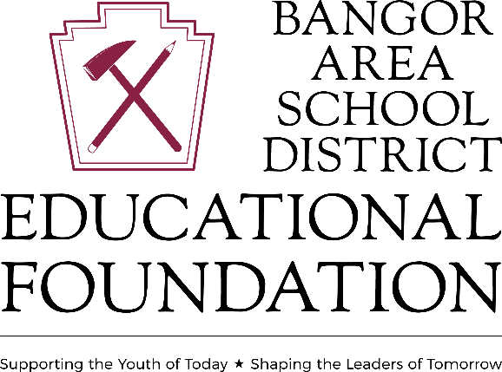

Portland High School Alumni Award
This is a one-time award in the amount of $1,000
Eligibility: Must be a resident of Portland Borough or Upper Mount Bethel Township
Student ID#: ___________________________________________
Address: __________________________________________________
Post-Secondary Institution: ________________________________
Post-Secondary Major: ____________________________________
Approximate Cost of Institution: ___________________________
***Included with your application, please list any school and non-school related activities you are active in:
The BASD Guidance department will attach a transcript to the application.
Application must be received by April 12, 2024. Applications can be submitted to the BASD Guidance department or directly to The BASD EDUCATIONAL FOUNDATION at director@basdef.org
Portland High School Alumni Award is a part of the Bangor Area School District Educational Foundation, Inc, which is a 501c3, non-profit educational organization whose mission is:
- To support learning for the children and adults of the Bangor Area School District by funding activities and culturally enriching programs, community events, student scholarships, teacher grant projects and academic awards.
- To encourage a life-long thirst for knowledge, self-improvement, and wisdom.
- To make a positive difference in the quality of life for all people in the Bangor Area School District.
- To encourage participation in the Foundation for individuals, civic groups, industries, and businesses. The goal of the Foundation is to enhance the educational quality of our students and improve the overall community. To learn more about Portland High School Alumni Award or the Educational Foundation or to submit a scholarship application, please visit, www.basdef.org.

